Nama Anggota:
- Arya Muda Siregar (Ketua) - 123450063
- Pramudya Wibowo (Anggota 1) - 121450030
- Khaalishah Zuhrah Alyaa Vanefi (Anggota 2) - 122450034
- May Talitha Dahlia (Anggota 3) - 123450009
- Khansa Anyaveda Liyantri (Anggota 4) - 123450099

- Start services
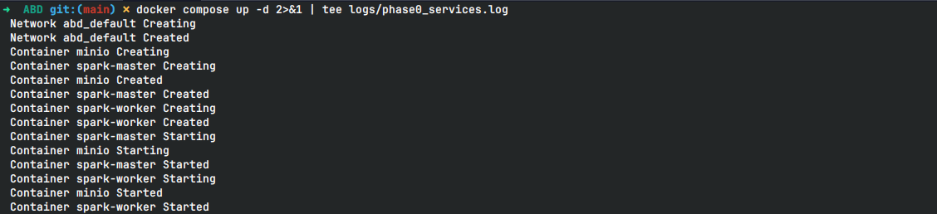
- Verify data
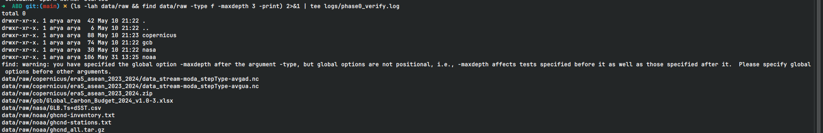

BRONZE LAYER
- Ingestion data
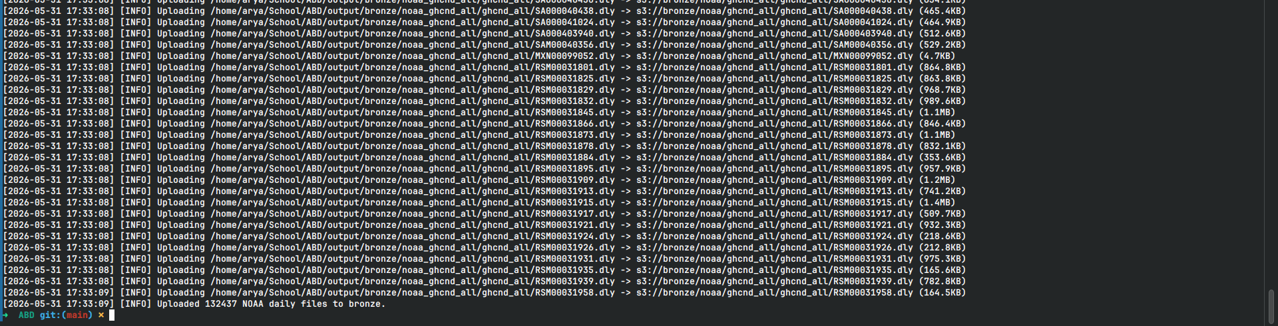
- Check di MinIO
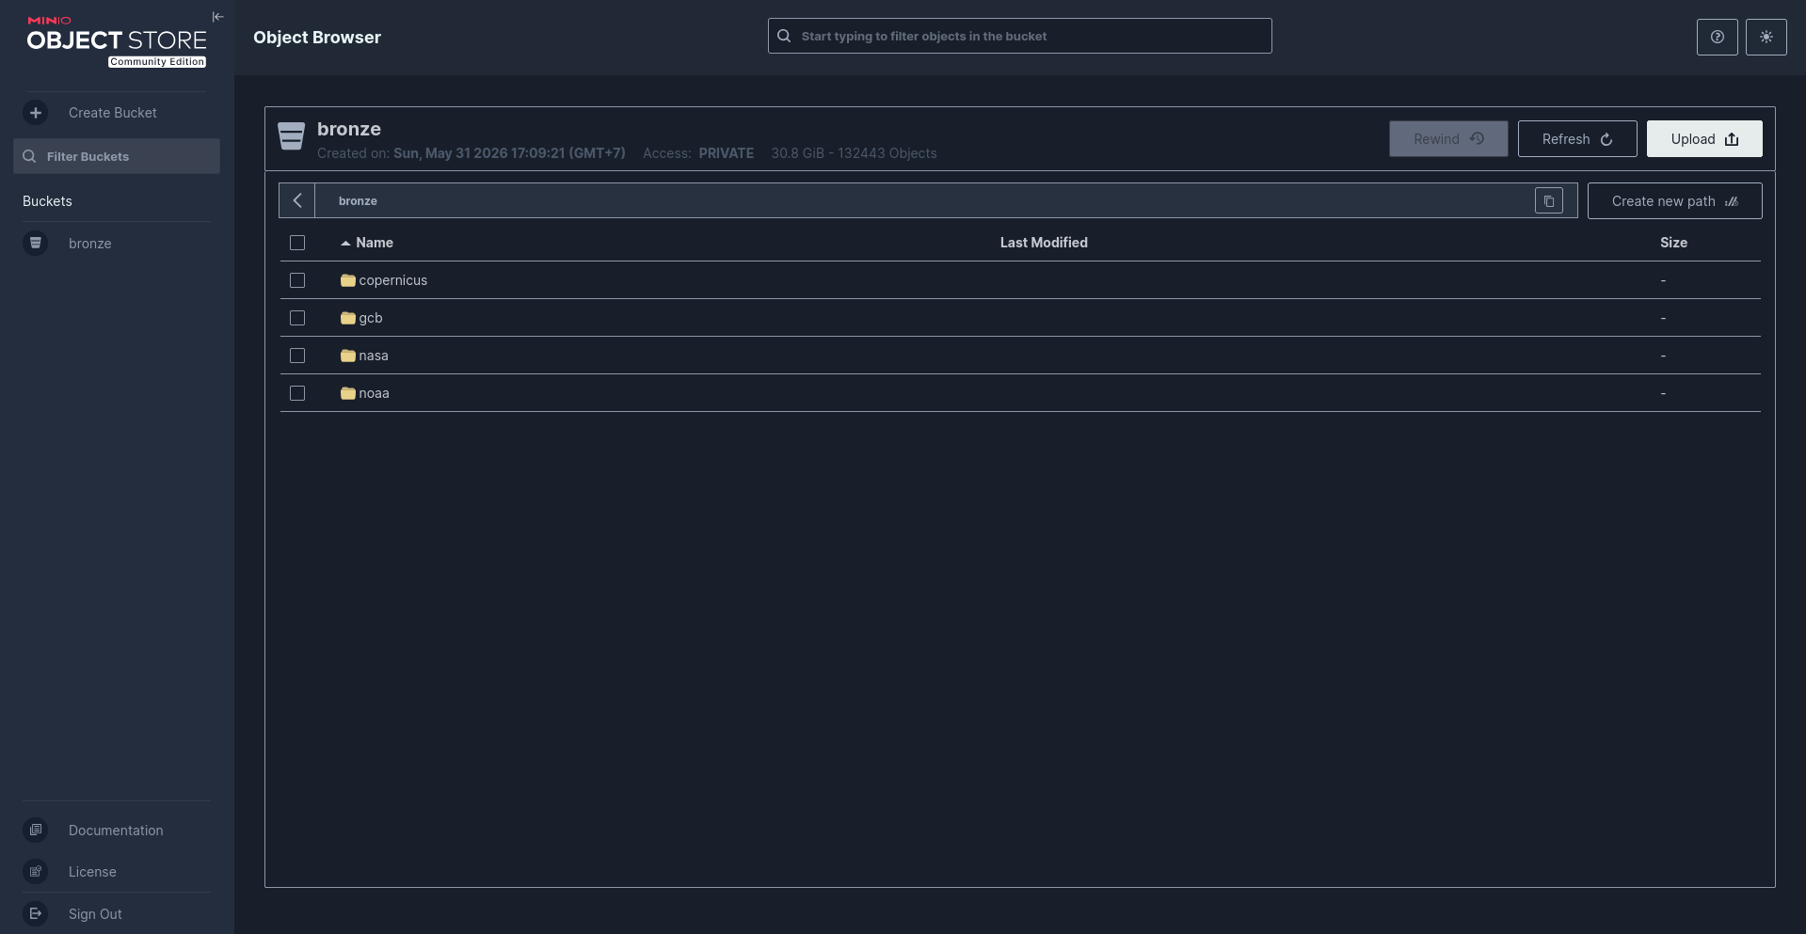

SILVER LAYER
- NASA GISTEMP cleaning
- Global Carbon Budget cleaning:
- ERA5 NetCDF normalization:
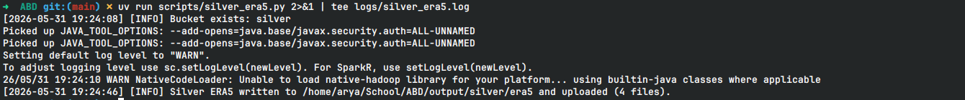
- NOAA GHCN-Daily filtering (ASEAN bounding box defaults):

GOLD LAYER
- Temperature trend aggregation (GISTEMP + ERA5)
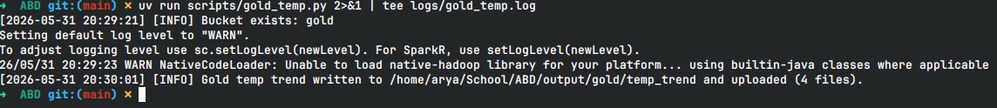
- Carbon emissions annual aggregation (GCB):
- Multi-source join (annual join of NASA + ERA5 + GCB):
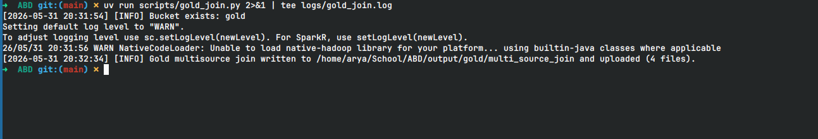

Baseline (DuckDB flat pipeline)

Evaluate

Report

Gold Layer
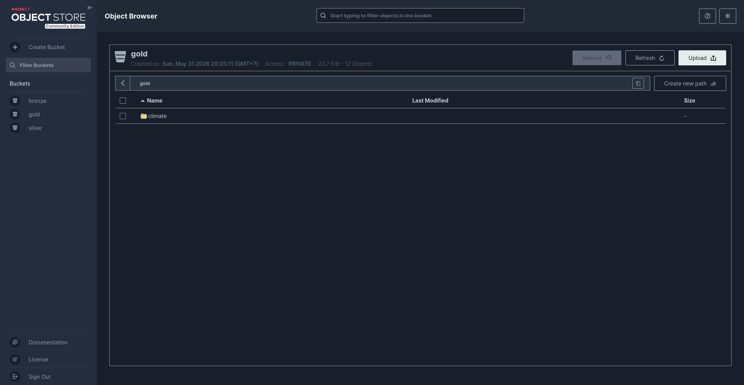

Silver Layer
